**Display Devices:**

Identify the names, purposes and characteristics of display devices, for example: projectors, CRT and LCD

* + Connector types (e.g. VGA, DVI / HDMi, S-Video, Component / RGB)
  + Settings (e.g. V-hold, refresh rate, resolution)

**Cathode Ray Tube (CRT):**

|  |  |  |
| --- | --- | --- |
|  | CRT display is the most commonly used form of visual displays, through it is getting gradually replaced with LCD and Plasma displays.  http://www.simulationexams.com/tutorials/aplus/essentials/images/display-monitor.jpg A computer monitor using CRT display.  In a CRT, an  electron beam sweeps the display screen horizontally, one line at a time, gradually down the screen. A synchronization (sync) signal brings the beam back to the top row of the display. This type of scanning (line-by-line) is known as raster scan. |  |

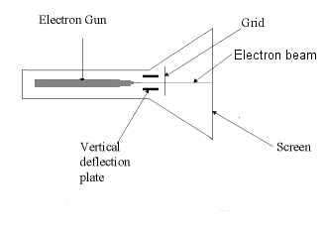

Figure: CRT cross sectional diagram showing important components of a CRT.

There are two types of cathode ray displays. One is non-interlaced, and the other is interlaced. Normally, all the displays are interlaced to reduce flicker.

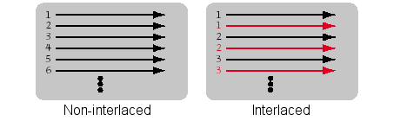

As shown in the figure, for non-interlaced display, the scanning is done continuously from top to bottom. For non-interlaced display, alternate rows are scanned.

A black and white monitor contains only one electron gun, whereas a color display monitor will have three electron guns, each of which represent red, green, and blue.

The horizontal and vertical deflection takes place by applying appropriate voltages to the horizontal, and vertical deflection plates. Usually, the screen is refreshed between 60-100 times per second.

The grid shown in the figure controls the speed with with the electrons hit the screen. If a positive voltage is applied to the screen grid, because of which the electrons are accelerated and hit the screen, making the screen brighter. If a negative voltage is applied to the grip, the electrons are decelerated and the screen will not glow. The microscopic control of electron beam flow, produces images on the screen.

One basic unit of measurement is "pixel" and stands for "picture element". A pixel is the smallest area in a graphics display that can be manipulated.

Given below are the commonly used screen resolutions:

|  |  |
| --- | --- |
| Display Type | Number of pixels |
| Video Graphics Array (VGA) | 640 * 480 pixels |
| Super Video Graphics Array(SVGA) | 800 * 600 pixels |
| eXtended Graphics Array (XGA) | 1024 * 768 pixels |
| Super eXtended graphics Array (SXGA) | 1280 * 1024 pixels |

Screen resolution is always stated as the horizontal number of pixels by the vertical number of pixels. A screen displaying 800 x 600 pixels has 600 rows, each 800 pixels wide.

Graphics Cards: The graphics card resides in the CPU box, and drives the video display. A typical graphics card is shown below:

|  |  |
| --- | --- |
| http://www.simulationexams.com/tutorials/aplus/essentials/images/graphic-adapter.jpg |  |

The graphics card shown includes DVI connector, TV/Video connector, and a VGA connector. The card has an on-board graphics processor with cooling fan. Usually, for graphic intensive applications, you need a higher end graphic adapter card. For normal desktop usage, a video adapter will be sufficient.

**LCD:**

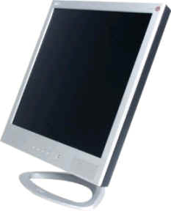

LCD monitors, as their name suggests, use liquid crystal display (LCD) technology. The LCD technology is very different form CRT technology. An LCD is a thin and flat display device compared to bulky, and heavy CRT.

LCD crystals are liquid chemicals that allow light to pass through themselves when aligned. By using electrical currents to varying degrees to align the crystals, it is possible to create the desired images and colors.

The liquid crystals are suspended between two pieces of polarized glass ("substrate"). The fluorescent light source emanates light that passes through the first substrate. The electrical currents then cause the crystals to align, allow varying levels of light to pass through to the second substrate, resulting in desired images being shown on the LCD screen.

There are two types of LCDs:

* Active-matrix, and
* Passive-matrix

 Most LCD monitors, along with LCD TVs, use active-matrix.

As with CRT, a pixel is a single point in a graphic image in CRT, and stands for "picture element". Each pixel on an LCD monitor comprises of three cells, red, green, and blue.

**Projector:**

The projector is useful when you need to show the contents of your seminar or lecture to a wider audience. A projector is almost always seen in any boardroom or a conference room.

There are primarily three types of projectors: LCD, DLP, and CRT

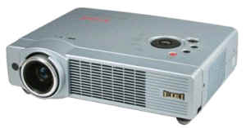

|  |  |
| --- | --- |
|  | LCD Projectors operate by emanating light through transparent LCD cells. Most LCD projectors use advanced polysillicon LCDs. They use three separate color panels (red, green, and blue) to produce the desired color. Projected images are produced by the combination of light emanating through the LCD cells. LCDs offer excellent color saturation, adjustable brightness and contrast. LCDs are typically brighter than DLPs at the same lumen output.  DLP Projector (Digital Light Processing): DLP projectors project images by reflecting lights against hundreds of tiny mirrors called digital micro devices (DMD). Each mirror representing one pixel, is powered by electronics that adjust the angle of the mirror according to the color being displayed. Compared to LCD projectors, DLP projectors are lighter in weight. Since DLPs have better contrast ratios, they project video images better than LCDs. They are portable, usually smaller and lighter than LCD projectors. |

CRT projectors are bulkier, and difficult to carry. These are hardly used in modern Projectors due their size. The disadvantage with DLP is its high cost.

Important parameters that you need to see when selecting a projector are:

* Resolution - The resolution of the projector should match that of your computer, or better. The following resolutions are normally used:
  + SVGA 800 x 600
  + XGA 1,024 x 768 (This is most widely used resolution)
  + SXGA 1,280 x 1,024 (High end personal computer users)
  + SXGA+ 1,400 x 1,050 (Good for photography/graphic presentation)
  + UXGA 1,600 x 1,200 (Expensive, but provides highest detail)
* Brightness:

 It is very important that the audience are able to see the presentation under unfavorable light conditions. If you have to do the presentation to a large audience, you may need to have high brightness, and vice versa. Another important factor is the ambient light. If the room is dark, a smaller brightness may be sufficient.

Trade shows, for example, require brighter images. Typically, you should have at least 1,000 lumens to project effectively in a lighted room.

* Color  
  Higher the number of colors a Project can support, better it is. Ensure that the Projector you buy display 16 million colors or more. This is adequate for most of the applications.
* Projector lamps: Projector lamps are one of the running costs associated with a projector. The lamp is the most expensive part of a projector. The lamp type is related to the image brightness. The most common types of projector lamp are the:

UHP - Ultra High Performance  
UHE - Ultra High Efficiency  
Metal halide lamps.

Lamp life is rated in hours. The typical lamp life for a projector is between 1,000 and 4,000 hours. A lower watt lamp will last longer, and costs less.

* Portability - Many a times, you may need to travel from place to place. If so, choose a light one.
* Compatibility - Ensure the interface compatibility with your computer hardware interfaces. Wireless mouse control is useful for wire free operation of the projector.

**Connector types (e.g. VGA, DVI / HDMi, S-Video, Component / RGB)**

**VGA connector:**

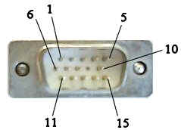

15 PIN HIGHDENSITY D-SUB MALE at the monitor cable.

|  |  |  |  |
| --- | --- | --- | --- |
| Pin Number | Pin Name | Direction | Description |
| 1 | Red | http://www.simulationexams.com/tutorials/aplus/essentials/images/arrow-r.gif | Red video |
| 2 | Green | http://www.simulationexams.com/tutorials/aplus/essentials/images/arrow-r.gif | Green video |
| 3 | Blue | http://www.simulationexams.com/tutorials/aplus/essentials/images/arrow-r.gif | Blue video |
| 4 | Reserved |  | Reserved |
| 5 | GND | http://www.simulationexams.com/tutorials/aplus/essentials/images/dot-black.gif | Ground |
| 6 | RGND | http://www.simulationexams.com/tutorials/aplus/essentials/images/dot-black.gif | Red Ground |
| 7 | GGND | http://www.simulationexams.com/tutorials/aplus/essentials/images/dot-black.gif | Green Ground |
| 8 | BGND | http://www.simulationexams.com/tutorials/aplus/essentials/images/dot-black.gif | Blue Ground |
| 9 | +5V | http://www.simulationexams.com/tutorials/aplus/essentials/images/arrow-r.gif | 5 V DC |
| 10 | SGND | http://www.simulationexams.com/tutorials/aplus/essentials/images/dot-black.gif | Sync Ground |
| 11. | ID0 | http://www.simulationexams.com/tutorials/aplus/essentials/images/arrow-l.gif | Monitor Id bit 0 (Optional) |
| 12. | SDA | http://www.simulationexams.com/tutorials/aplus/essentials/images/arrow-lr.gif | DDC Serial Data Line |
| 13. | HSYNC or CSYNC | http://www.simulationexams.com/tutorials/aplus/essentials/images/arrow-r.gif | Horizontal Sync (or Composite Sync) |
| 14. | VSYNC | http://www.simulationexams.com/tutorials/aplus/essentials/images/arrow-r.gif | Vertical Sync |
| 15. | SCL | http://www.simulationexams.com/tutorials/aplus/essentials/images/arrow-lr.gif | DDC Data Clock Line |

**DVI:**

The Digital Display Working Group (DDWG) has developed the Digital Visual Interface (DVI) as a video interface standard to maximize the visual quality of digital display devices (eg. flat panel LCDs, and digital projectors). DVI-D is compatible with HDMi standard.

There are three types of DVI connector:

* DVI-D (digital only)
* DVI-A (analog only)
* DVI-I (digital & analog)

The connector also includes provision for a second data link for high resolution displays. This type of connector is referred to as DVI-DL (dual link).

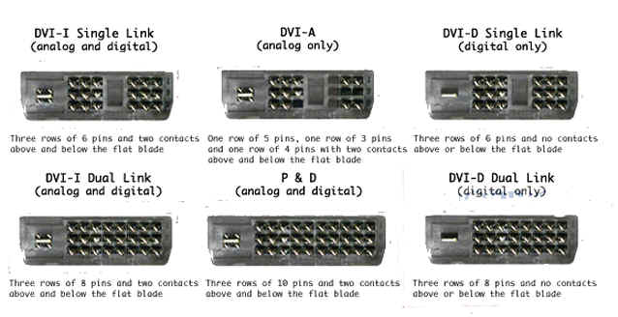

**The High-Definition Multimedia Interface (HDMI):**

 This is an all-digital audio/video interface that provides connectivity between any compatible digital audio/video source, such as a set-top box, a DVD player, a PC, or a video game console and a compatible digital audio and/or video monitor, such as a digital television (DTV).

|  |  |
| --- | --- |
| http://www.simulationexams.com/tutorials/aplus/essentials/images/s-video-cable.jpg | http://www.simulationexams.com/tutorials/aplus/essentials/images/s-video-socket.jpg |
|  |  |

It is considered as a replacement for older standards such as RF - coaxial cable, S-Video, VGA, and DVI. HDMI is backward compatible with the single-link Digital Visual Interface carrying digital video (DVI-D or DVI-I, but not DVI-A) used on computer monitors and graphics cards.

**S-Video**

S-Video, short for "Separate Video", is an analog video signal that carries the video data as two separate signals (brightness and color), unlike composite video which carries the entire set of signals in one signal line. The 4-pin Mini-DIN connector (shown at right) is the most common of several types of S-Video connectors.

|  |  |  |  |  |
| --- | --- | --- | --- | --- |
| http://www.simulationexams.com/tutorials/aplus/essentials/images/s-video-conn.gif | Pin No. | Name | Description | http://www.simulationexams.com/tutorials/aplus/essentials/images/s-video-conn.jpg |
| 1 | GND | Ground (Y) |
| 2 | GND | Ground (C) |
| 3 | Y Intensity (Luminance) | 75 Ohms |
| 4 | C Color (Chrominance) | 75 Ohms |
| Pin-out Configuration | Pins Description | | | S-Video Cable |

S-video does not carry audio on the same cable. It is mostly used to output a PC's video signal to a Television.

**Settings (e.g. V-hold, refresh rate, resolution)**

**V-hold:**

V-Hold adjusts Vertical Hold. Use this if screen is having uncontrollable scrolling.

**Refresh rate:**

The refresh rate (or "vertical refresh rate", "vertical scan rate" for CRTs) is the number of times that the screen is refreshed. This is distinct from the measure of frame rate in that the refresh rate includes the repeated refreshment of identical frames, while frame rate measures how often a display can change from one image to another.

For example, a movie projector advances from one frame to another 24 times each second. But each frame is refreshed twice before the next frame is projected. As a result, the movie projector runs at 24 frames per second, but has a 48 Hz refresh rate.

To change the refresh frequency for your monitor (Windows 2000 OS):

1. Open Display dialog box in Control Panel.  
2. On the Settings tab, click Advanced.  
3. On the Monitor tab, in the Refresh Frequency list, click a new refresh rate.  
4. After making the changes, you have 15 seconds to confirm the change. Click Yes to confirm the change; click No or do nothing to revert to your previous setting. If you see "Out of Sync" message, and nothing else on the screen, just keep quiet. The previous settings will be restored.

**Resolution:**

Resolution refers to the number of individual pixels contained in a screen display. Resolution is expressed by identifying the number of pixels on the horizontal axis (rows) and the number on the vertical axis (columns), such as 1024x768. Monitor size and screen resolution work together to determine the physical size of objects displayed on the screen. Commonly used screen resolutions include 640x480, 800x600, 1024x768, 1152x864, 1280x1024, and 1600x1200.  
To change your screen resolution (Windows 2000 OS)

1. Open Display dialog box in Control Panel.  
   2. On the Settings tab, under Screen resolution, drag the slider, and then click Apply.  
   3. When prompted to apply the settings, click OK. Your screen will turn black for a moment.  
   4. After making the changes, you have 15 seconds to confirm the change. Click Yes to confirm the change; click No or do nothing to revert to your previous setting. If you see "Out of Sync" message, and nothing else on the screen, just keep quiet. The previous settings will be restored.

**Computer cooling** is required to remove the [waste heat](http://en.wikipedia.org/wiki/Waste_heat) produced by [computer components](http://en.wikipedia.org/wiki/Computer_components), to keep components within permissible [operating temperature](http://en.wikipedia.org/wiki/Operating_temperature) limits.

To fill poorly conducting air gaps due to imperfectly flat and smooth surfaces, a thin skim of [thermal grease](http://en.wikipedia.org/wiki/Thermal_grease), a [thermal pad](http://en.wikipedia.org/wiki/Thermally_conductive_pad), or [thermal adhesive](http://en.wikipedia.org/wiki/Thermal_adhesive) may be interposed between the component and heatsink.

solid material (often [paraffin wax](http://en.wikipedia.org/wiki/Paraffin_wax) or[silicone](http://en.wikipedia.org/wiki/Silicone) base)

heatsink(al or cu)

Common fan sizes include 40, 60, 80, 92, 120, and 140 square mm. 200 and 230 mm fans are sometimes used in high-performance personal computers

**Dust**

**Poor airflow**

**Poor heat transfer**